**Laboratory work 1**

**Purpose of work**: the acquisition of basic skills in working with modeling software packages MATLAB.

* 1. **Basic information**

MATLAB is a high-level programming system that works as an interpreter and includes a large set of commands for performing a wide variety of calculations, defining data structures and graphical representations of information. In particular, it uses the commands of the Control System Toolbox application package designed for working with LTI-models (Linear Time Invariant Models) of control systems.

MATLAB Simulink is an interactive tool for modeling, analysis and synthesis of dynamic systems based on a library of blocks. Simulink is a fairly independent MATLAB tool, but access to the MATLAB functions and its other tools remains open. There are also additional block libraries for various applications (simulation of electrical devices, a set of blocks for the development of digital devices, etc.).

* 1. **Main principles of work and modelling**

The laboratory work of this workshop is carried out on the basis of either the CST command or the MATLAB Simulink operating units. To work with CST, you must run the MATLAB program and then work in the command window of the MATLAB environment (Figure 1.1), using the set of commands given in the laboratory.

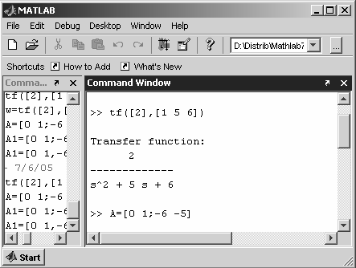

*Командное окно MATLAB*

*Команды CST*

Figure 1.1 – Command window of MATLAB

To work with MATLAB Simulink, after starting MATLAB, you need to open File→New→Model in the menu. In the window that opens (Figure 1.2), system models from the operating units of the Simulink library are assembled.

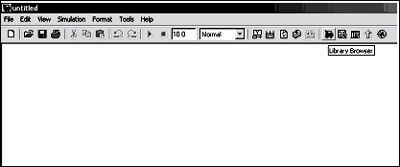

Figure 1.2 – Window MATLAB Simulink

The block library window is launched by pressing the Library Browser button in the Simulink menu and consists of various application sections (Figure 1.3).

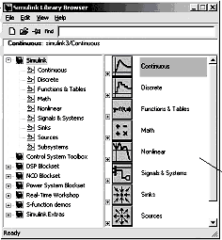

Library Partition List

Window of the contents of the library section (list of sub-sections of the library or blocks)

Figure 1.3 –MATLAB Simulink

* 1. **Methodical example**

Modeling an n-th order equation with initial conditions using MATLAB tools.  
Let a differential equation be given:

|  |  |
| --- | --- |
|  | (1.1) |

With initial conditions *y(t0) = 1, y / (t0) = 1,* t *∈[t0,+∞], t0 = 0*.

The simulation scheme of equation (1.1) in MATLAB Simulink is shown in Figure 1.4. To construct the scheme, it was necessary to solve equation (1.1) with respect to the highest derivative:

|  |  |
| --- | --- |
|  | (1.2) |

and use the standard blocks in MATLAB Simulink: adder (Sum), integrator (Integrator), gain (gain), block output characteristics - an oscilloscope (Scope).

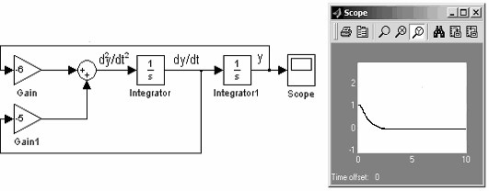

*«gain» block*

*Adder*

*Block «Scop»*

*y*(*t*)

*Integrator*

*d* 2 *y*

*dt* 2

 5  6 *y*

*dy*

*dt*

Figure 1.4 - Modeling equation (1.2) in MATLAB Simulink

* 1. **The order of laboratory 1 execution**

1.4.1 Run the MATLAB program. View the contents of the menu.

1.4.2 Assemble the circuit of Figure 1.4, arbitrarily changing the parameters of the simulated elements and the initial conditions. Write the equation of the model.

1.4.3 Model the differential equation of the first and third order:

|  |  |
| --- | --- |
| with initial condition |  |
| with initial conditions | |

Parameters and initial conditions are chosen independently or set by the teacher. 1.4.3 In the command window.